Analysis procedure

- Turn the response variable (growth rate) into an effect size (between 0, no effect and 1, no growth)
ES=(max[gr]-gr)/max[gr]

First approach: concentration addition (same mode of action, no interaction)

- Calculate a stress index for each stressor (SI_{stressor})
SI_{stressor} = α_{stressor} x Δstressor
with Δstressor = Stressor – Reference [0.14 for Li, 19.7 for temp]
or Δstressor = Reference - Stressor [8.0 for pH]
Start with α_{stressor} = 1 (to be adjusted later)

- Adjust α_{stressor} under the assumption of concentration addition (same mode of action and each driver relatively contributing to the stress)
Calculate the overall stress index under concentration addition (SI_{CA}) as:
SI_{CA} = SI_{Li} + SI_{pH} + SI_{Temp}
Plot the relationship between SI_{CA} and ES for each experiment
(See SICA_preadjustement sheet in the xls file)
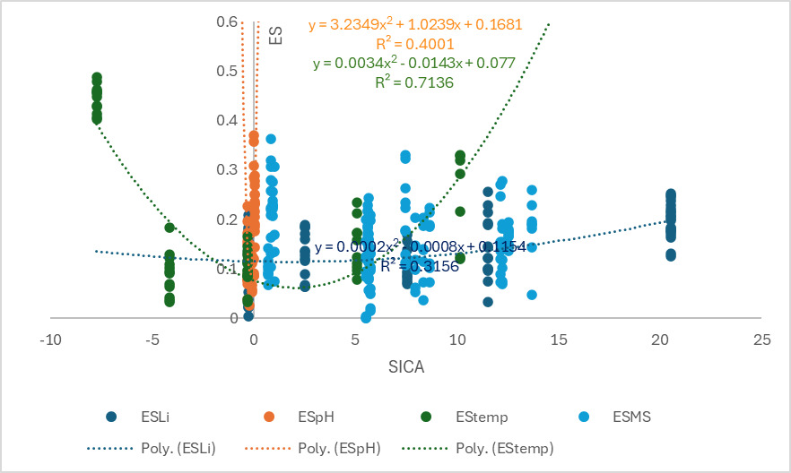
You can the adjust the Alpha values for Li and pH till the curves align (first assumption being that all stressors have the same mode of action and thus having the same shape performance curve)
With α_{Temp} = 1, α_{Li} = 0,35 and α_{pH} = 28, we have a nice looking fit (in the future, there must be a way to automatize this, I did it manually)
(See SICA_adjusted sheet in the xls file)

If you compare all the single stressors with multiple ones, you then have
(See SICA_adjusted (2) sheet in the xls file)
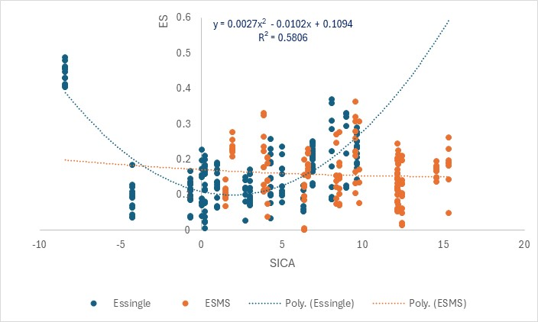
Not such a great fit for the MS with values above 10 which correspond to pHxTemp and pHxTempxLi with the model over-estimating the impact.

Stop here – we don’t have the data to go further - EPJ
Second approach: Different mode of actions

- Make the performance curves for all the stressors
Use a polynomial regression on the Effect Size as calculated in 1.
(See Performance curves sheet in the xls file)

- Use the performance curves to calculate the predicted effect under the assumption of different mode of action
For each stressor, calculate the expected effect size from regressions: ES_{temp}, ES_{pH}, ES_{Li}
The modelled effect size can then be calculated as
ES_{model} = ES_{temp} + ES_{pH} + ES_{Li} – ES_{temp}xES_{pH} - ES_{temp}xES_{Li} – ES_{pH}xES_{Li} + ES_{pH}xES_{temp}xES_{Li}
You can then plot ES_{model} vs. ES_{obs} for the different experiments
(See Different mode of actions curves sheet in the xls file)
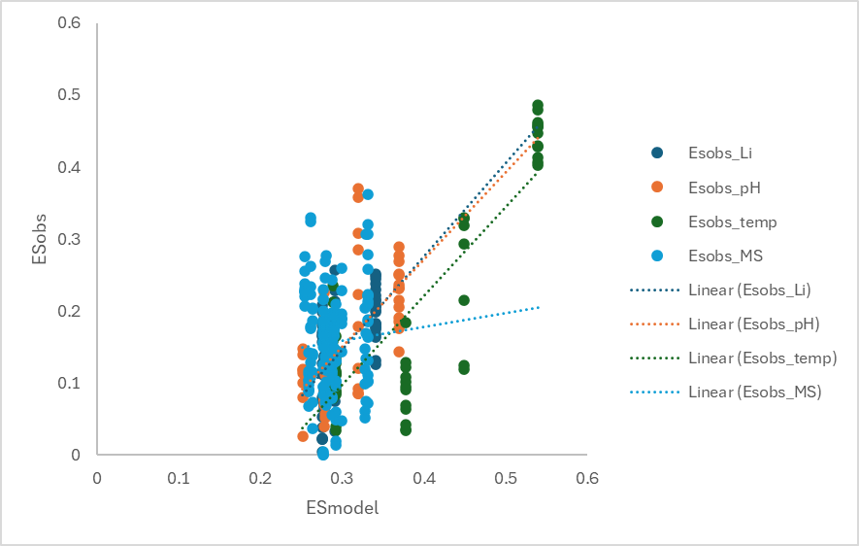
Seems an under-estimation of the lithium treatment and

Third approach – hybrid model
A little stuck there, tried many approaches but the resolution of the multiple stressor data is not great and difficult to have a clear picture. Let’s brainstorm

